Driving Fun Begins with
Tappahannock Carriages!

Current Inventory

The Back-to-Back Slat-Sided Trap/Full-Size Horses
List price: $8,500
Demonstrator price: $7,250

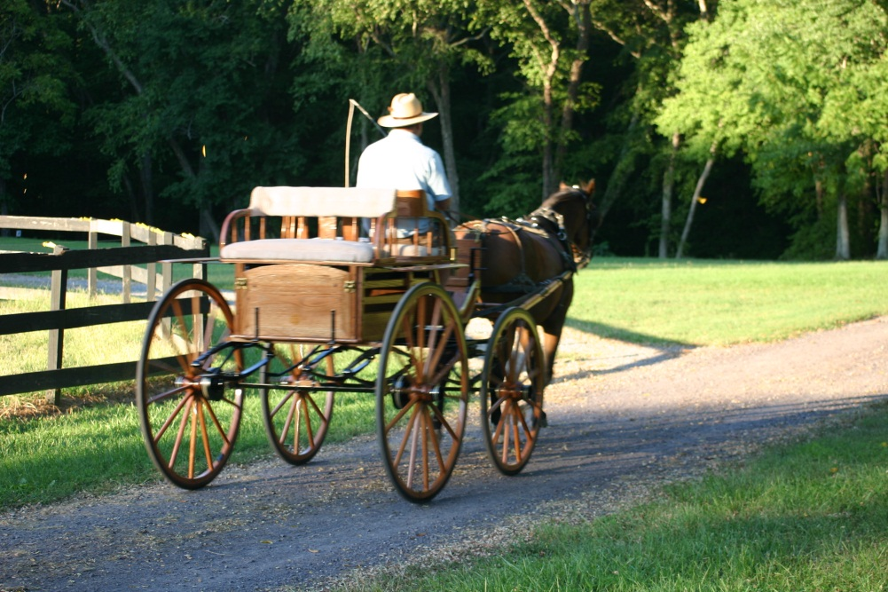

This solid oak Trap has a brass rein rail, whip holder and other hardware and spindle seats; it fits a 14 to 15+-hand horse (pair or single). The wheels are offset spokes on rubber, and the carriage is equipped with hydraulic brakes and four-spring suspension with fifth wheel and cut under. The rear trunk lid is used as a foot rest when open and provides access to the storage area. Pole and shafts are included.

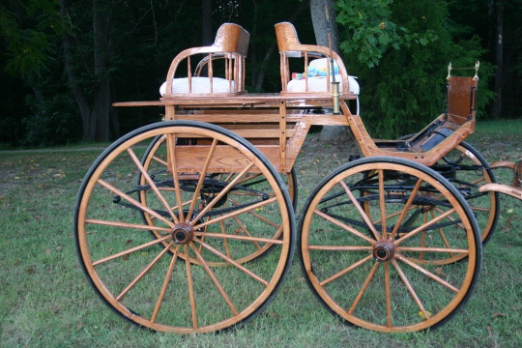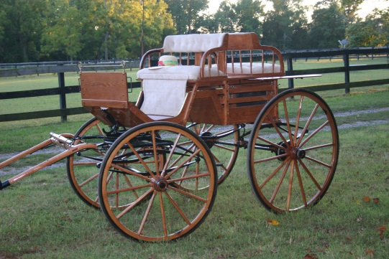

The Back-to-Back Slat-Sided Trap for Minis/Small Ponies
List price: $4,800
Demonstrator price: $4,250

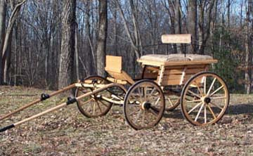

This fun little carriage, a slat-sided, back-to-back trap, has been designed for a large miniature horse or a pony. The Trap has block brakes, offset spokes, wheels on rubber with roller bearings, a drop-front axle, and a heavier, three-spring suspension. Solid oak with a natural finish, the carriage comes with a rein rail, a whip holder, shafts for a single horse, and a pole for a pair. Zeus, a 38-inch mini is pulling the carriage, which is, with slight variations, a scaled-down version of the full-size back-to-back trap shown on page one.

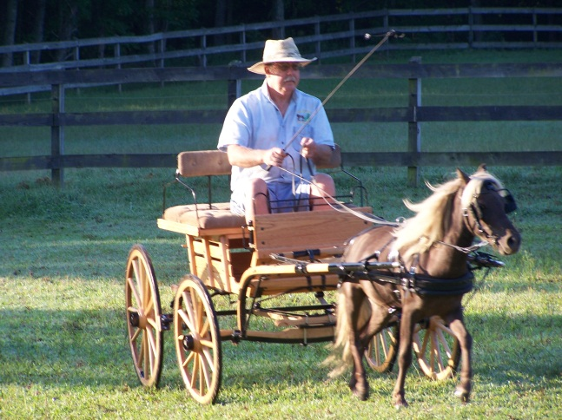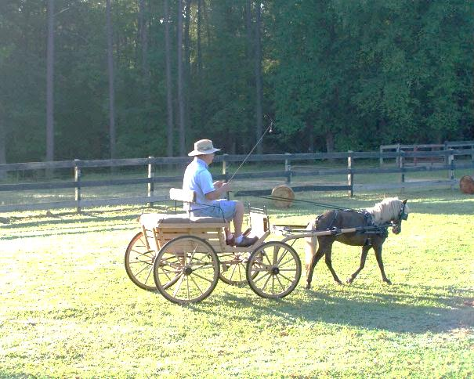

The Runabout
List price: $3,850
Sale price: $2,850

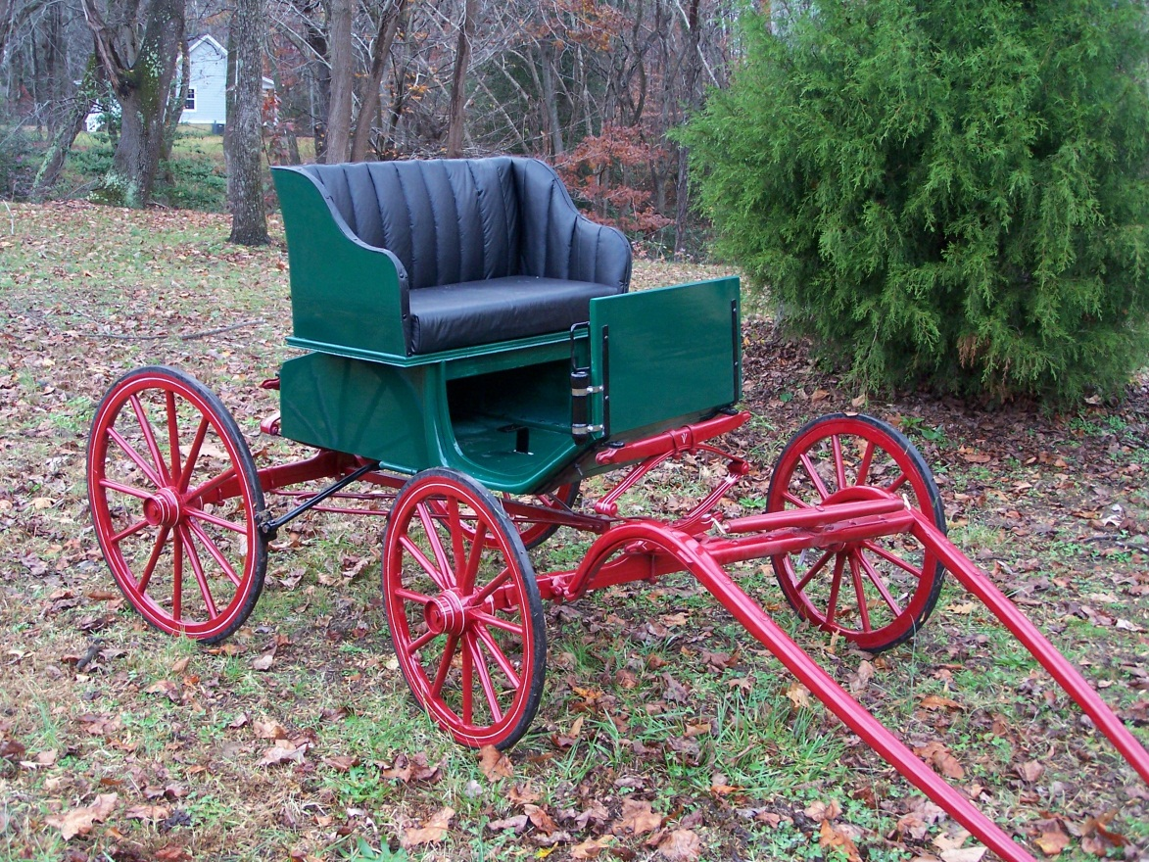

This little runabout is made of solid poplar with oak bracing. It has mechanical brakes, a small functional trunk, offset spoke wheels with roller-bearing hubs. The carriage weighs less than 200 lbs. Hot Rod, a 31-inch mini, easily pulls the carriage. Add a pole for a pair of minis for $650. Have a full-size horse? Call us! Tappahannock Carriages can build this design for any size horse!

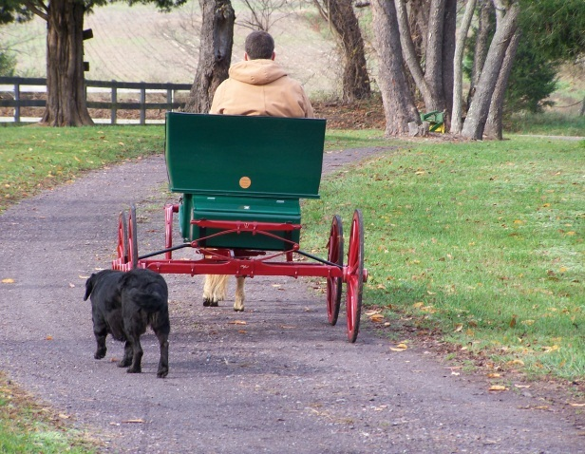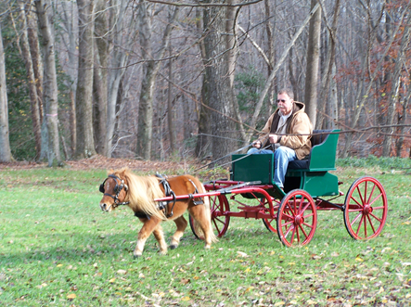

The Road Cart
List price: $2,150

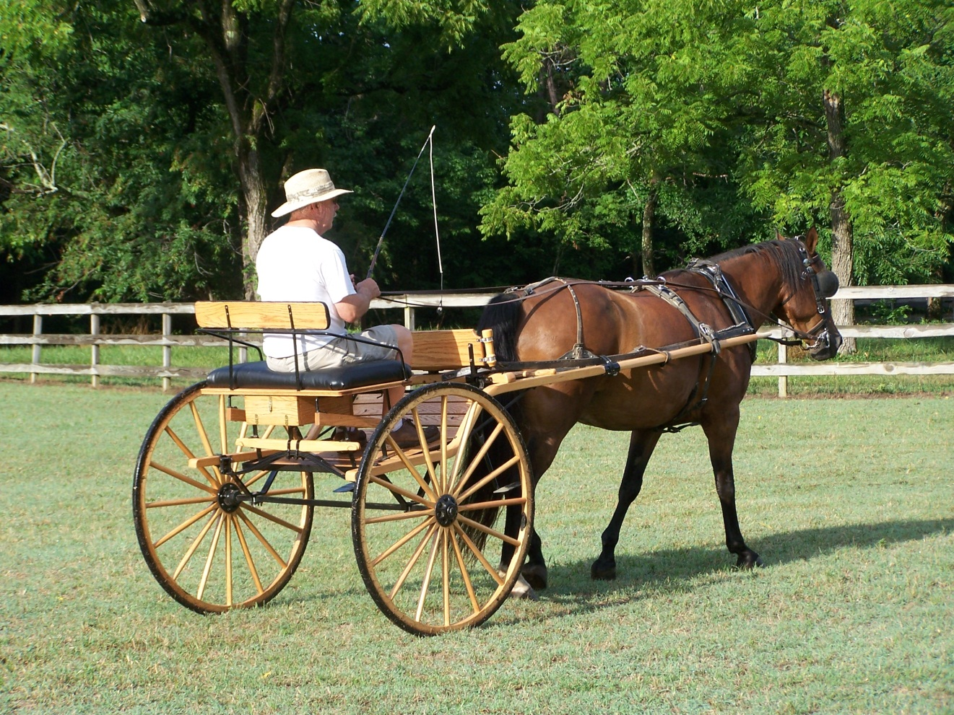

This front-entry road cart has wheels on rubber and flush hubs. Store your spares kit in the handy storage box that’s tucked under the seat. The natural oak finish complements the dash board and black rein rail and whip holder. Shown with a 15.1-hand horse.

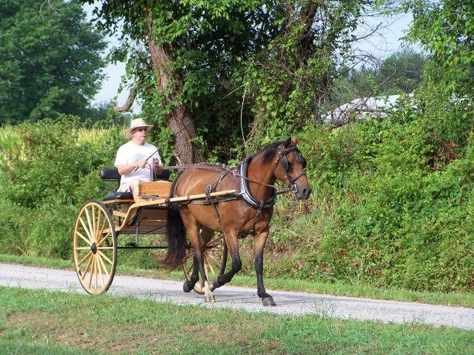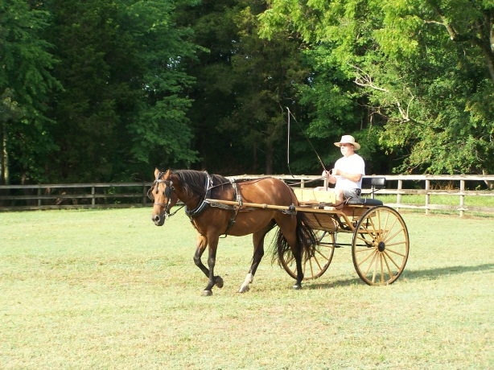

Previously Driven and Gently Used Carriages!

The MeadowB rook with Leather Harness
List price: $3,000
Drastically Reduced Sale price: $1,800

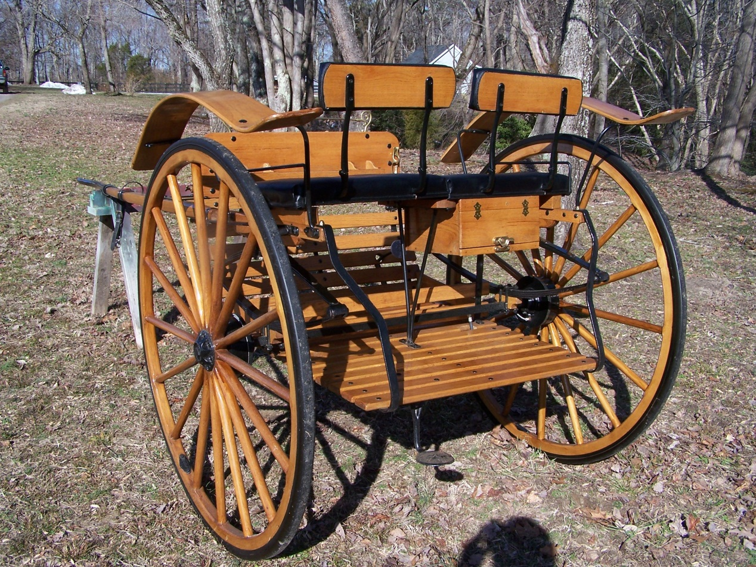

This MeadowBrook has all the options: brass rein rail, spares box, rear entry through flip-up seat, springs/flexi-shaft, and BRAKES! Wheels-48 inches with flush hubs. Also included: black leather harness with brass fittings and russet reins! It fits a 15+-hand horse. The harness TRULY is in LIKE NEW condition. Don’t let this cart/harness combo pass you by. It’s a must have!
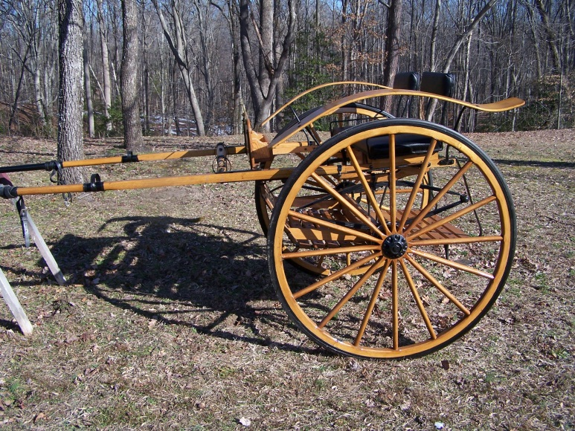

The Marathon
List price: $3,800

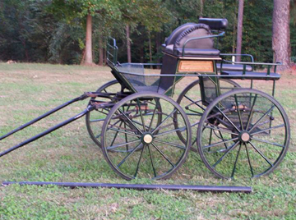

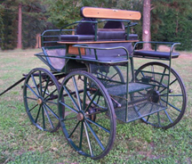
This lightweight hunter green marathon, built by Mill Run Carriages, comes with a pole and shafts. A full cut under, the carriage has rear drum brakes, a ball-bearing fifth wheel,
aluminum spoke wheels, and a wedge seat. NEVER abused.

The McLaughlin Phaeton
List price: $4,500
Sale price: $3,950

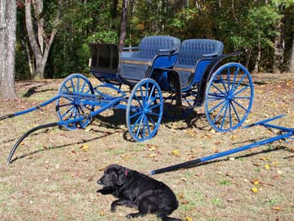
This four-spring
Phaeton, built by McLaughlin Carriage Company of Oshawa, Canada, has been
restored and comes
with pole and shafts. (Dog not included)
The carriage has block brakes, tight wheels, and nice, blue wool
upholstery...a very
comfortable ride for
four adults!
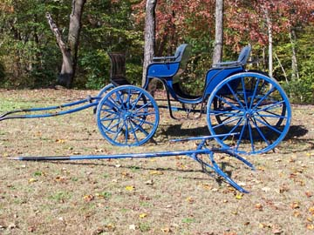
The Farm Wagon
List price: $1,400

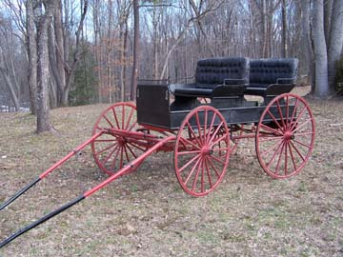

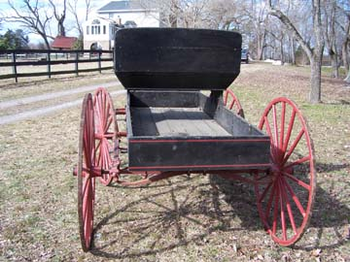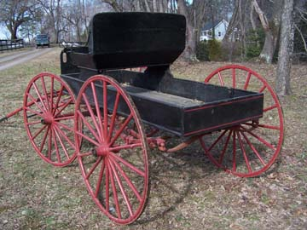

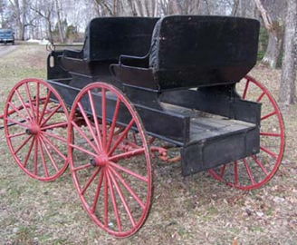

This farm wagon has removable seats and shafts for a single horse. It has nice combination heavy springs. It is in good shape!
The Cart
List price: $550

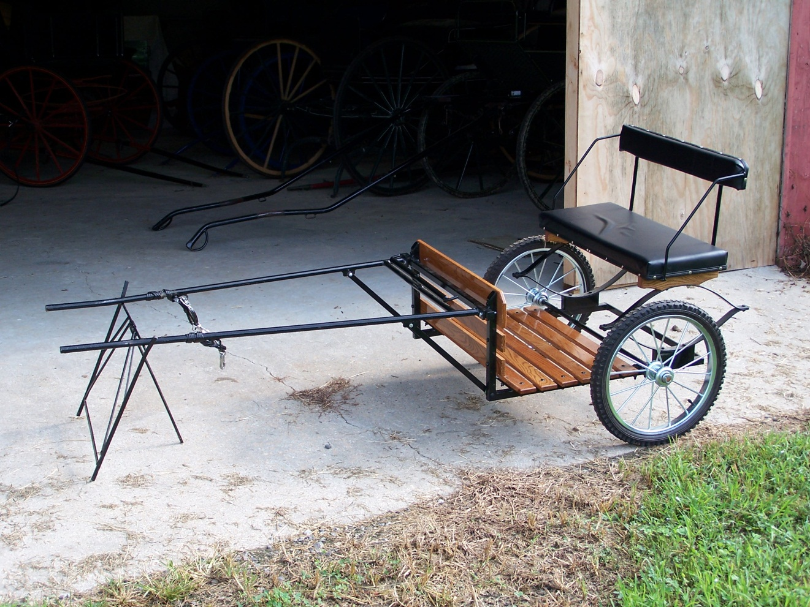

This cart is in excellent condition and perfect for a little mini. It’s very light, comfortable, and ready to go! Below, Zeus and Hot Rod are pulling similar carts.

Driving fun begins with Tappahannock Carriages!

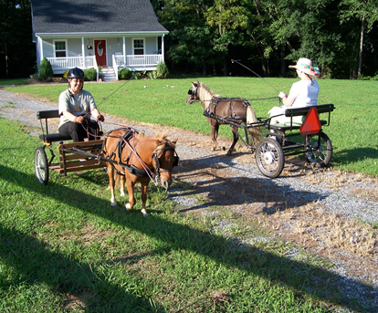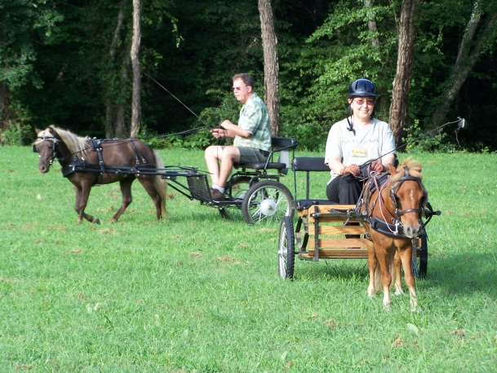

The Matching Sleigh and Carriage
List price: $3,800

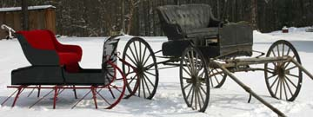

This freshly restored sleigh is perfect for enjoying the winter snow! It has a matching carriage in original condition. The carriage is very drivable — good wheels on rubber. The sleigh and carriage will be sold as a pair. The carriage can be sold as is or restored for an additional fee.

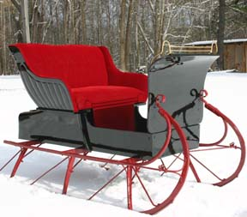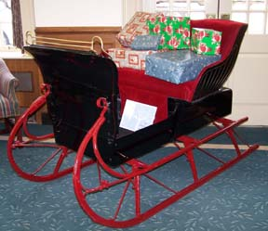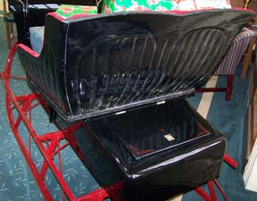

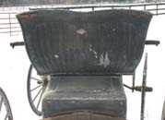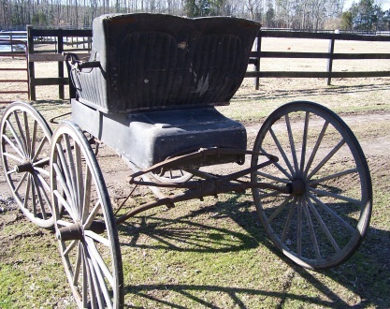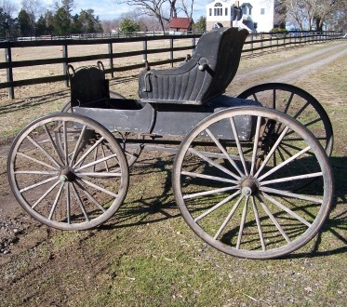

Sold, but we can build one for you!

The Roadster

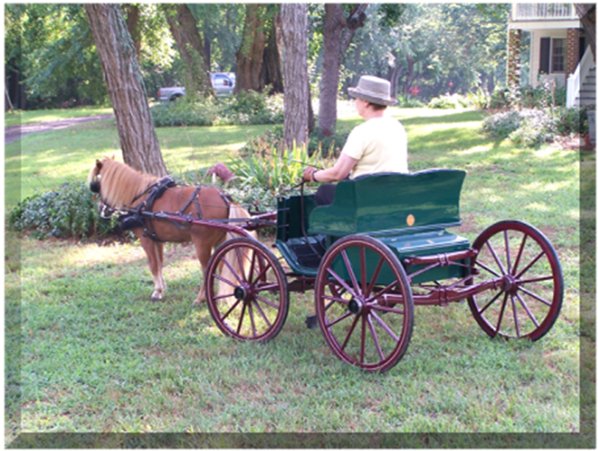

This smooth riding runabout is made of solid poplar with oak bracing and brass trimming. It has mechanical brakes, a small functional trunk, offset spoke wheels with roller-bearing hubs, and dropped axles to lower the center of gravity. The carriage weighs less than 200 lbs. Hot Rod, a 31-inch mini, pulls the carriage with ease.

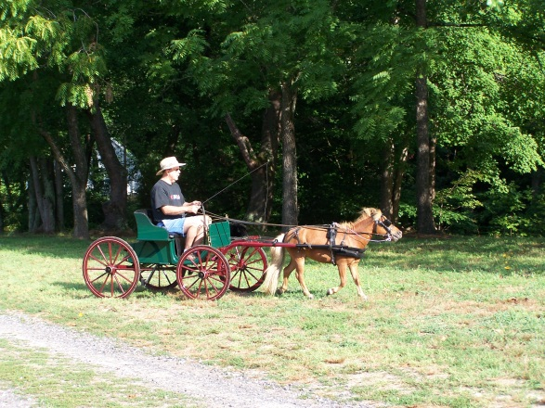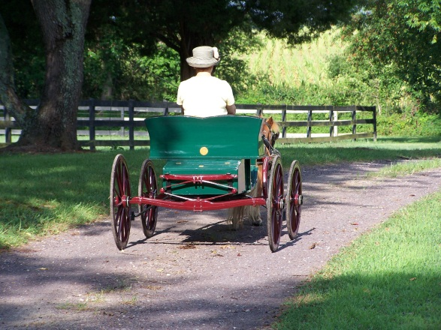
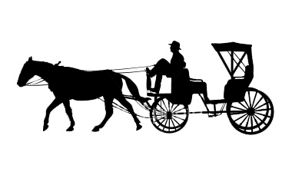

Contact Randy at Tappahannock Carriages today to purchase one of the carriages listed in this brochure, or to order a custom built carriage. Tappahannock Carriages builds and restores carriages and sleighs to fit miniature horses, ponies, and full-size horses.

What can we build for you?

Randy Silvers
(804) 443-3636 office
(804) 241-5200 cell
www.tappahannockcarriages.com
randy@tappahannockcarriages.com

